Project Media List

<https://www.insidelacrosse.com/>

<https://lacrosseunlimited.com/>

<https://www.lax.com/>

<https://www.stx.com/?SID=43vea10t6md6d7o4t330qhl1su>

Syracuse University “INFLCR” app (photos taken by SU media)

Various Instagram account for videos

<https://www.espn.com/watch/>



(pictures of myself playing lacrosse for SU)



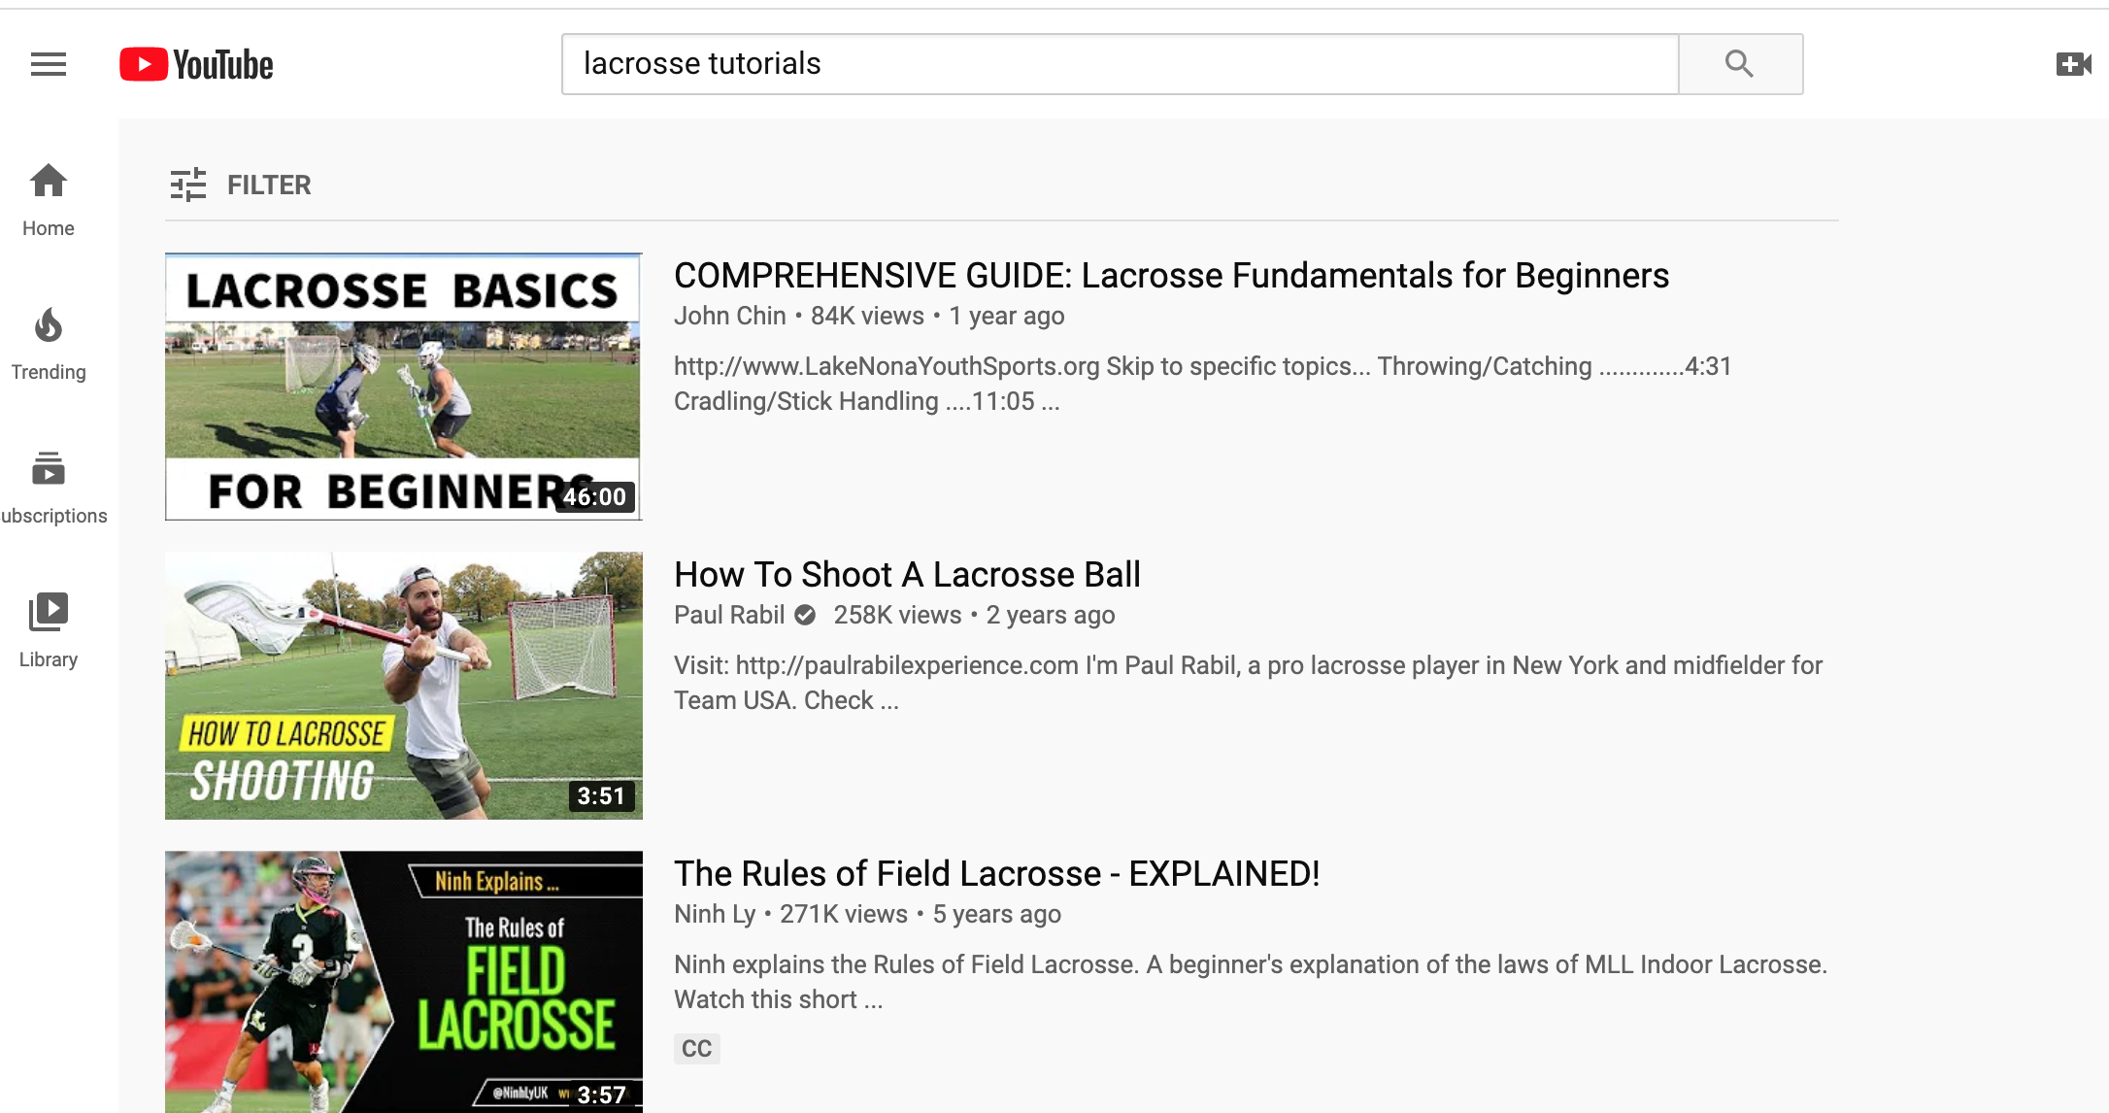

(how to videos/ informational videos I can use from other people… or even better, make the videos of myself and teammates doing drills